**UKF COLLEGE OF ENGINEERING & TECHNOLOGY**

**PARIPPALLY.KOLLAM**

**INTERNET OF THINGS CST-448**

**SEMESTER 8- 2023-24 BATCH**

**Question and Answers**

**MODULE 1**

(Part A carries 3 marks)

1. Explain the role of IoT in connected roadways ?

Ans:The Internet of Things (IoT) is making road transportation more connected, safe, sustainable, and efficient with traffic management, pedestrian and vehicle safety, environmental monitoring, smart and connected roadway corridors, and EV charging and parking networks.Smart roads use Internet of Things (IoT) devices to make driving safer, more efficient, and in line with government objectives, greener. Smart roads combine physical infrastructures such as sensors and solar panels with software infrastructure like AI and big data.

Smart road technologies are embedded in roads and can improve visibility, generate energy, communicate with autonomous and connected vehicles, monitor road conditions, and more.With new pressures for cities to develop more effective roadways and highways, smart infrastructure is essential for modernization. Smart roads built on IoT and information and communications technology (ICT) can make it possible for cities and transportation authorities to collect and analyze data to improve day-to-day traffic management. Smart road infrastructure can also help cities adapt for long-term sustainable transportation needs. With IoT sensors, cameras, radar, and 5G-equipped technologies, data can be analyzed in near-real time and used to improve congested roadways, streamlining traffic flow. Data can also be sent to the cloud for long-term analysis, providing critical insight for efforts such as reducing CO2 emissions.

Edge computing opens myriad possibilities for smart and connected roads. It enables low latency for the analytics and artificial intelligence (AI) that power smart road infrastructure, like adaptive traffic lights and integrated roadways. For example, traffic lights that automatically adjust their timing based on sensor data can enhance the flow of traffic or change signals to help protect others on the road from dangerous drivers.

1. Describe the functions of the various layers of simplified IoT Architecture Model.?

IoT architecture can comprise up to seven layers, which are known as the perception, transport, edge, processing, application, business, and security layers.

#### 1) Perception Layer

The **perception** layer of an IoT system architecture, also known as the device layer, consists of multiple elements – sensors, cameras, actuators, and similar devices that gather data and perform tasks.

#### 2) Transport Layer

The **transport** layer of an IoT system architecture transmits data from multiple devices (e.g., on-site sensors, cameras, actuators) to an on-premise or cloud data center.

#### 3) Edge Layer

As IoT networks grow in scale, latency becomes one of the main performance challenges, as numerous devices connecting to a hub end up congesting the network. By enabling data processing and analysis as close to the source as possible, edge computing addresses these problems – which is handled through the **edge** layer of an IoT system architecture.

#### 4) Processing Layer

A fundamental component of an IoT system architecture is its **processing** layer, also called the middleware layer, which typically leverages many connected computers simultaneously, in the form of [cloud computing](https://dgtlinfra.com/cloud-internet-of-things-iot/), to deliver superior compute, storage, networking, and security performance.

1. Write the benefits of IoT?And their Impact?

The following examples illustrate some of the benefits of IoT and their impact.

* + 1. Connected Roadways
    2. Connected Factory
    3. Smart Connected Buildings
    4. Smart Creatures

##### Connected Roadways

IoT is going to allow self-driving vehicles to better interact with the transportation system around them through bidirectional data exchanges while also providing important data to the riders. Connected roadways is the term associated with both the driver and driverless cars fully integrating with the surrounding transportation infrastructure.Most connected roadways solutions focus on resolving today’s transportation challenges such as

* 1. Safety 2. Mobility 3. Environment

##### Connected Factory

For years, traditional factories have been operating at a disadvantage, impeded by production environments that are “disconnected” or, at the very least, “strictly gated” to corporate business systems, supply chains, and customers and partners. Managers of these traditional factories are essentially “flying blind” and lack visibility into their operation.

##### Smart Connected Buildings

The function of a building is to provide a work environment that keeps the workers comfortable, efficient, and safe. Work areas need to be well lit and kept at a comfortable temperature. To keep workers safe, the fire alarm and suppression system needs to be carefully managed, as do the door and physical security alarm systems. While intelligent systems for modern buildings are being deployed and improved for each of these functions. Sensors are often used to control the heating, ventilation, and air-conditioning (HVAC).

##### Smart Creatures

IoT also provides the ability to connect living things to the Internet. Sensors can be placed on animals and even insects just as easily as on machines, and the benefits can be just as impressive. One of the most well-known applications of IoT with respect to animals focuses on what is often referred to as the “connected cow.” Sparked, a Dutch company, developed a sensor that is placed in a cow’s ear.

4.Write the main challenges facing manufacturing in a factory environment today?

* Accelerating new product and service introductions to meet customer and market opportunities
* Increasing plant production, quality, and uptime while decreasing cost
* Mitigating unplanned downtime
* Securing factories from cyber threats
* Decreasing high cabling and re-cabling costs
* Improving worker productivity and safety

5.Describe the main elements of one M2M IoT architecture?

oneM2M architecture divides IoT functions into three major domains:

* 1. The application layer,
  2. The services layer, and
  3. The network layer.

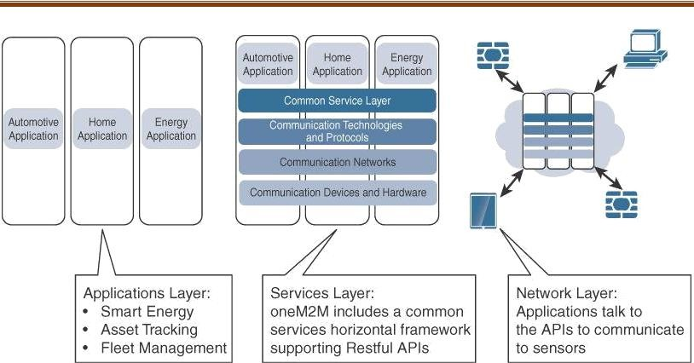

6.Define IoTWF?

In 2014 the IoTWF architectural committee (led by Cisco, IBM, Rockwell Automation, and others) published a seven-layer IoT architectural reference model. While various IoT reference models exist, the one put forth by the IoT World Forum offers a clean, simplified perspective on IoT and includes edge computing, data storage, and access.

It provides a succinct way of visualizing IoT from a technical perspective. Each of the seven layers is broken down into specific functions, and security encompasses the entire model.the IoT Reference Model defines a set of levels with control flowing from the center (this could be either a cloud service or a dedicated data center), to the edge, which includes sensors, devices, machines, and other types of intelligent end nodes.

In general, data travels up the stack, originating from the edge, and goes northbound to the center. Using this reference model, we are able to achieve the following:

* Decompose the IoT problem into smaller parts.
* Identify different technologies at each layer and how they relate to one another.
* Define a system in which different parts can be provided by different vendors.
* Have a process of defining interfaces that leads to interoperability
* Define a tiered security model that is enforced at the transition points between levels.

7.Define IoT reference model layer and functions?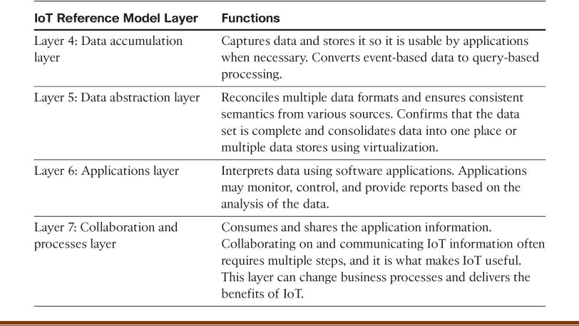

PART B

1. Illustrate the impact of IoT in at least 2 domains of normal human life?

##### Connected Roadways

IoT is going to allow self-driving vehicles to better interact with the transportation system around them through bidirectional data exchanges while also providing important data to the riders. Connected roadways is the term associated with both the driver and driverless cars fully integrating with the surrounding transportation infrastructure.Most connected roadways solutions focus on resolving today’s transportation challenges such as

* 1. Safety 2. Mobility 3. Environment

By addressing the challenges in Table 1.2. Connected roadways will bring many benefits to society. These benefits include reduced traffic jams and urban congestion, decreased casualties and fatalities, increased response time for emergency vehicles, and reduced vehicle emissions.For example:

With IoT-connected roadways, a concept known as Intersection Movement Assist (IMA) is possible. This application warns a driver (or triggers the appropriate response in a self-driving car) when it is not safe to enter an intersection due to a high probability of a collision—perhaps because another car has run a stop sign or strayed into the wrong lane. Thanks to the communications system between the vehicles and the infrastructure, this sort of scenario can be handled quickly and safely. Figure 1.4 for a graphical representation of IMA.

##### Connected Factory

For years, traditional factories have been operating at a disadvantage, impeded by production environments that are “disconnected” or, at the very least, “strictly gated” to corporate business systems, supply chains, and customers and partners. Managers of these traditional factories are essentially “flying blind” and lack visibility into their operations. These operations are composed of plant floors, front officers, and suppliers operating in independent silos.

Consequently, rectifying downtime issues, quality problems, and the root causes of various manufacturing inefficiencies is often difficult.

The main challenges facing manufacturing in a factory environment today include the following:

❖

Accelerating new product and service introductions to meet customer and market opportunities

* Increasing plant production, quality, and uptime while decreasing cost
* Mitigating unplanned downtime
* Securing factories from cyber threats

2.Describe IoT Architecture and design?

Enterprise IT network architecture has matured significantly over the past two decades and is generally well understood; however, the discipline of IoT network architecture is new and requires a fresh perspective.

It is important to note that while some similarities between IT and IoT architectures do exist, for the most part, the challenges and requirements of IoT systems are radically different from those of traditional IT networks.

The terminology is also different to the point where IoT networks are often under the umbrella of OT, which is responsible for the management and state of operational systems. In contrast, IT networks are primarily concerned with the infrastructure that transports flows of data, regardless of the data type.

##### Drivers Behind New Network Architectures

While IT systems are mostly concerned with reliable and continuous support of business applications such as email, web, databases, CRM systems, and so on. IoT is all about the data generated by sensors and how that data is used. The essence of IoT architectures thus involves how the data is transported, collected, analyzed, and ultimately acted upon.

**Comparing IoT Architectures**

Two of the best-known architectures are

1. oneM2M and
2. The IoT World Forum (IoTWF)

##### 1.The oneM2M IoT Standardized Architecture

In an effort to standardize the rapidly growing field of machine-to-machine (M2M) communications, the European Telecommunications Standards Institute (ETSI) created the M2M Technical Committee in 2008.

The goal of this committee was to create a common architecture that would help accelerate the adoption of M2M applications and devices. Over time, the scope has expanded to include the Internet of Things.The goal of oneM2M is to create a common services layer, which can be readily embedded in field devices to allow communication with application servers. oneM2M’s framework focuses on IoT services, applications, and platforms. These include smart metering applications, smart grid, smart city automation, e-health, and connected vehicles.

oneM2M architecture divides IoT functions into three major domains:

1.The application layer,

2.The services layer, and

3.The network layer

##### Applications layer:

The oneM2M architecture gives major attention to connectivity between devices and their applications. This domain includes the application-layer protocols and attempts to standardize northbound API definitions for interaction with business intelligence (BI) systems. Applications tend to be industry-specific and have their own sets of data models, and thus they are shown as vertical entities.

1. **Services layer:**

This layer is shown as a horizontal framework across the vertical industry applications. At this layer, horizontal modules include the physical network that the IoT applications run on, the underlying management protocols, and the hardware.

##### Network layer:

This is the communication domain for the IoT devices and endpoints. It includes the devices themselves and the communications network that links them. Embodiments of this communications infrastructure include wireless mesh technologies, such as IEEE 802.15.4, and wireless point-to-multipoint systems, such as IEEE 801.11ah. Also included are wired device connections, such as IEEE 1901 power line communications.

3.Describe the Standardized IoT architectures.?

In 2014 the IoTWF architectural committee (led by Cisco, IBM, Rockwell Automation, and others) published a seven-layer IoT architectural reference model. While various IoT reference models exist, the one put forth by the IoT World Forum offers a clean, simplified perspective on IoT and includes edge computing, data storage, and access.

It provides a succinct way of visualizing IoT from a technical perspective. Each of the seven layers is broken down into specific functions, and security encompasses the entire model.

As shown in Figure 2.2, the IoT Reference Model defines a set of levels with control flowing from the center (this could be either a cloud service or a dedicated data center), to the edge, which includes sensors, devices, machines, and other types of intelligent end nodes.

In general, data travels up the stack, originating from the edge, and goes northbound to the center. Using this reference model, we are able to achieve the following:

* Decompose the IoT problem into smaller parts.
* Identify different technologies at each layer and how they relate to one another.
* Define a system in which different parts can be provided by different vendors
* Have a process of defining interfaces that leads to interoperability
* Define a tiered security model that is enforced at the transition points between levels.

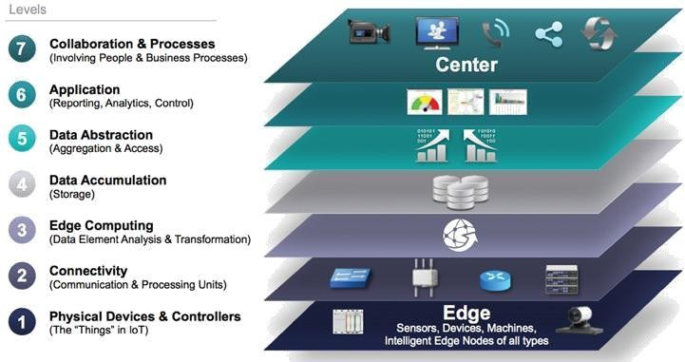

##### Layer 1: Physical Devices and Controllers Layer

The first layer of the IoT Reference Model is the physical devices and controllers layer. This layer is home to the “things” in the Internet of Things, including the various endpoint devices and sensors that send and receive information. The size of these “things” can range from almost microscopic sensors to giant machines in a factory. Their primary function is generating data and being capable of being queried and/or controlled over a network.

##### Layer 2: Connectivity Layer

In the second layer of the IoT Reference Model, the focus is on connectivity. The most important function of this IoT layer is the reliable and timely transmission of data. More specifically, this includes transmissions between Layer 1 devices and the network and between the network and information processing that occurs at Layer 3 (the edge computing layer).

##### Layer 3: Edge Computing Layer

At this layer, the emphasis is on data reduction and converting network data flows into information that is ready for storage and processing by higher layers. One of the basic principles of this reference model is that information processing is initiated as early and as close to the edge of the network as possible.

**Upper Layers: Layers 4–7**

The upper layers deal with handling and processing the IoT data generated by the bottom layer. For the sake of completeness.